Unity developer assignment

*Read the instructions carefully.*

* You have to develop an android application in Unity.
* Design an Augmented Reality application.
* Use the images given below for your reference.
* You can also replicate the design we provided in the reference images given below.
* For submission add the .apk file and the image target file in github and mail us the link.

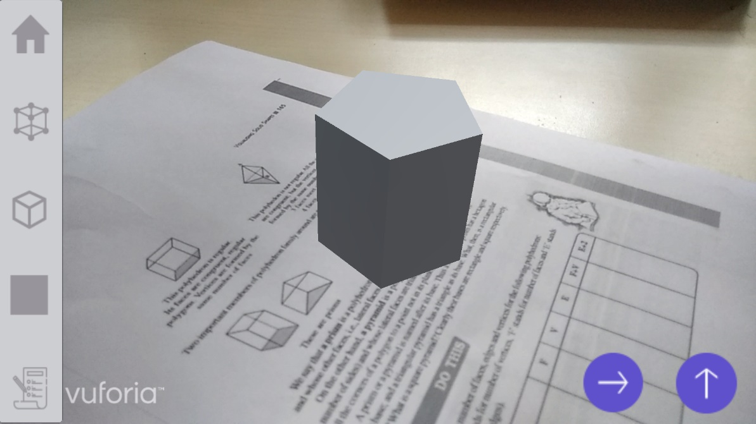

Fig 1

In the above image (fig 1) you can see the 3D model of pentagonal prism is augmented over the image target which is a text book page.

WHAT YOU HAVE TO DO?

STEP 1 - Choose any image of your choice as an image target and augment the pentagonal prism over it.

STEP 2 – Use Blender 3D for modelling 3D model of pentagonal prism and import the model in unity.

STEP 3 - Design the vertex selection button, the vertex selection button (fig 2) will enable user to select the vertices of the pentagonal prism when user presses the corner of the Pentagonal prism.

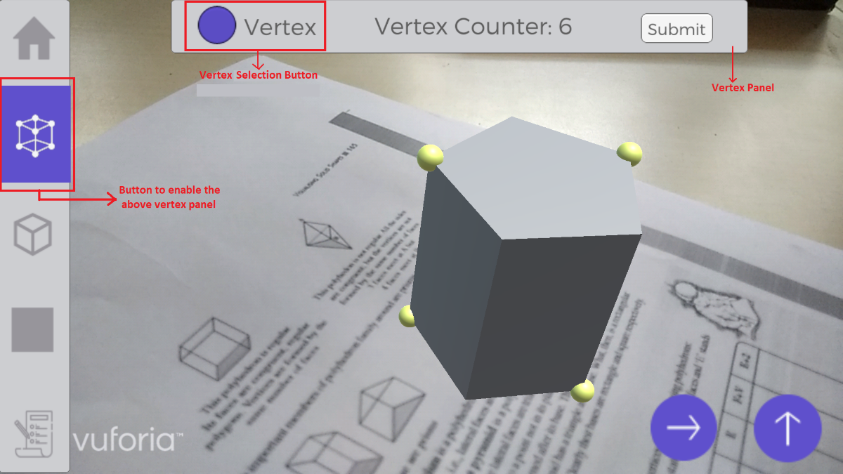

Fig 2

STEP 4 - Write a C# script in Unity IDE, which will allow user to enable the vertices of the pentagonal prism.

STEP 5 - When the vertices are enabled, counter value must increment showing the current number of enabled vertices (fig 2).

* Design a submit button (fig 3) which will give a feed back when you submit your answer.

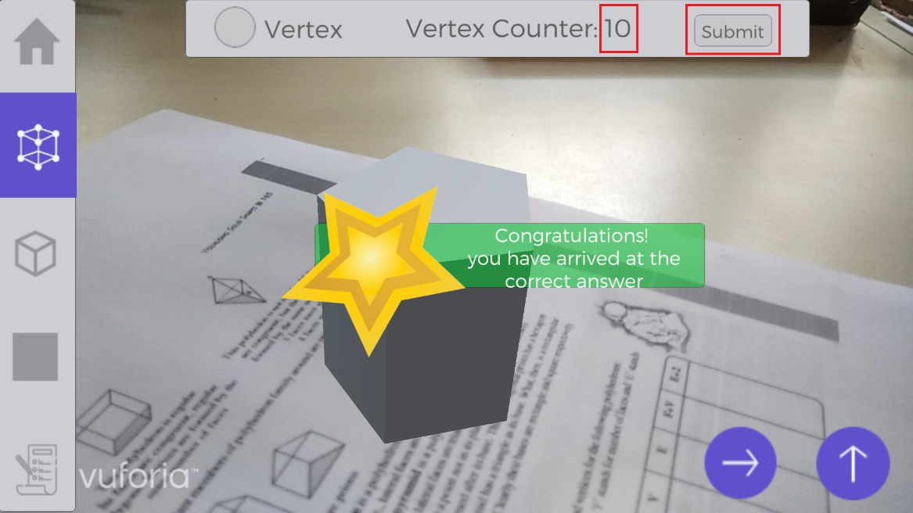

Fig 3

* The pentagonal prism has 10 vertices, if user submits right answer by selecting 10 vertices, app must give the positive feedback. (fig 3)

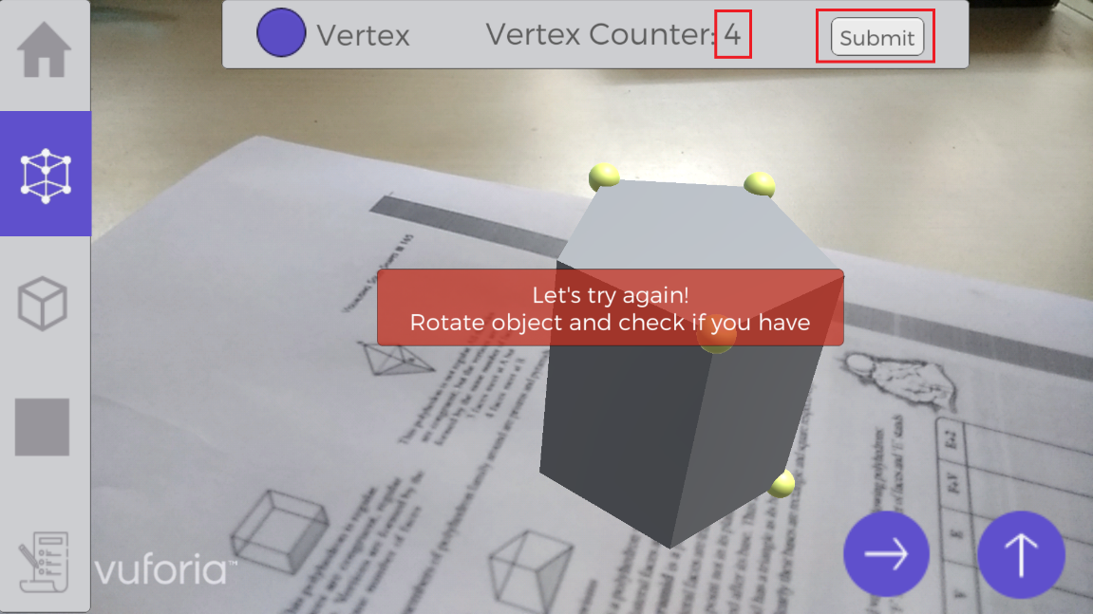

Fig 4

* If user submits wrong answer for e.g. 4 vertices, app must give the negative feedback. (fig 4)
* Similarly, also design a face selection button (fig 5). If user selects that and touches the vertices, no function will be performed. (for designing purpose)

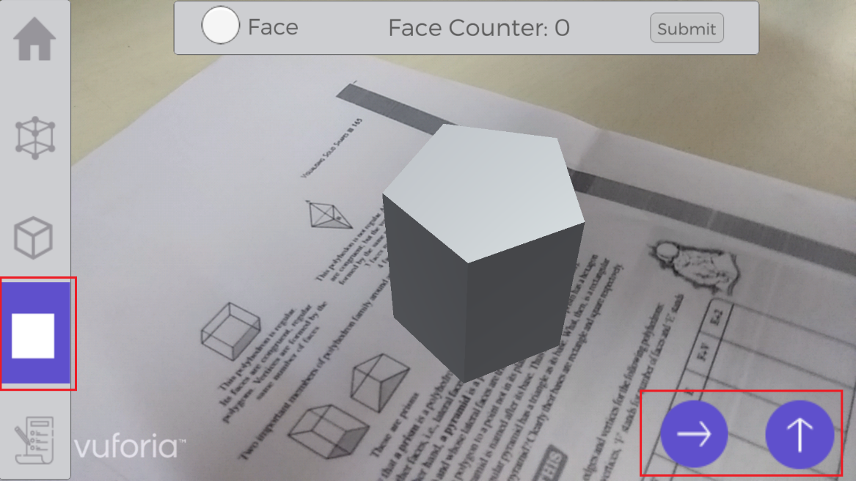

Fig 5

STEP 6 – Also design two buttons using C# script which when pressed will rotate the prism along X and Z axis.